**Verification of Elastic Equilibrium Solutions**

Verifying that the particular solution satisfies:

$$-η_{l}η_{j}C_{ijkl}{\hat{u}}_{k}(\vec{η})={iη_{j}C}_{ijkl}{\hat{ε}}_{kl}^{0}(\vec{η})$$

We get three independent equations for $i=1,2,3$. The left hand side for $i=1$ is:

$${\hat{LHS}}_{1}=C_{11}η_{1}^{2}{\hat{u}}_{1}+C_{44}η_{2}^{2}{\hat{u}}_{1}+C_{44}η_{3}^{2}{\hat{u}}_{1}+C_{12}η_{1}η_{2}{\hat{u}}_{2}+C_{44}η_{1}η_{2}{\hat{u}}_{2}+C_{12}η_{1}η_{3}{\hat{u}}_{3}+C_{44}η_{1}η_{3}{\hat{u}}_{3}$$

The right hand side for $i=1$ is:

$${\hat{RHS}}_{1}=-iC_{11}{\hat{ε}}_{11}^{0}η_{1}-iC_{12}{\hat{ε}}_{22}^{0}η_{1}-iC_{12}{\hat{ε}}_{33}^{0}η_{1}-2iC_{44}{\hat{ε}}_{12}^{0}η_{2}-2iC_{44}{\hat{ε}}_{13}^{0}η_{3}$$

Numerically, we can verify that that $LHS-RHS≈0:$

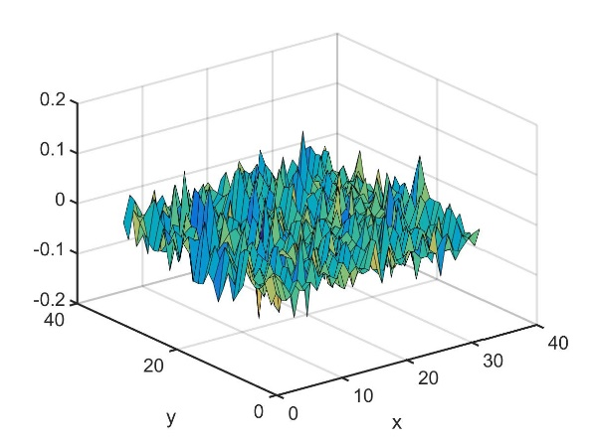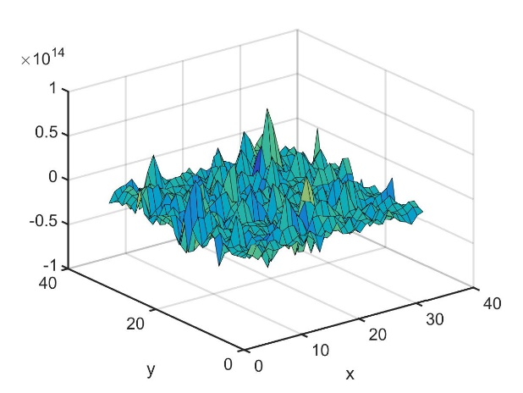

$LHS-RHS≈0.$ $RHS$ is on the order of 1014, which makes any nonzero values in $LHS-RHS$ due to numerical errors. Plot a layer of each.

We can also verify the homogenous solution that was solved via Yu Luan Li’s 2D FFT method. Again we have three equations which we can verify the LHS and RHS.

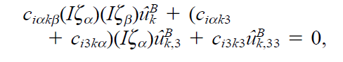

For $i=1,$

$$C44*{\hat{u}}_{1,33}^{B}-C11*η_{1}^{2}*{\hat{u}}_{1}^{B}-C44*η_{2}^{2}*{\hat{u}}_{1,33}^{B}+η_{1}*{\hat{u}}_{1,3}^{B}*\left(C12*1i+C44*1i\right)-C12*η_{1}*η_{2}*{\hat{u}}_{2}^{B}-C44*η_{1}*η_{2}*{\hat{u}}_{2}^{B}=0$$

In the 2D Fourier space:

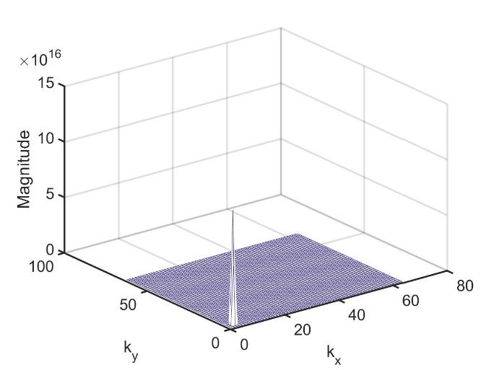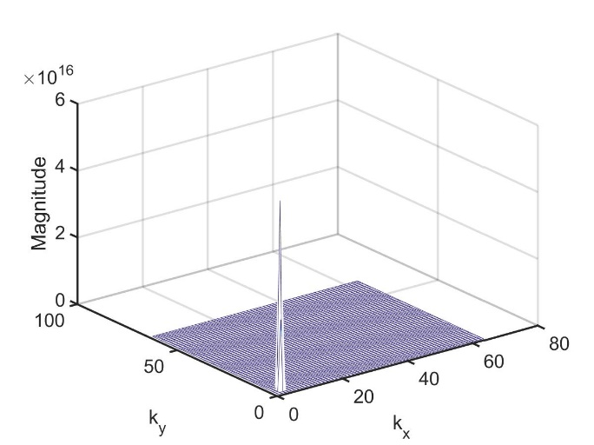

$C44*{\hat{u}}_{1,33}^{B}$. $C11*η_{1}^{2}*{\hat{u}}_{1}^{B}$. Note that both are on the order of 1016

The total LHS is:

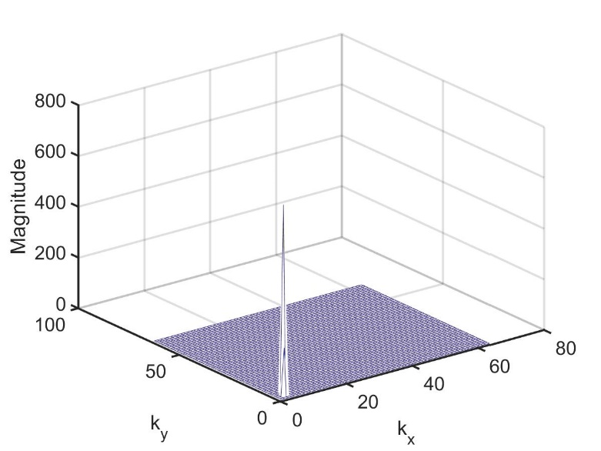

Not exactly zero but close enough considering it was originally ~1016

**Maybe plot the functions in real space???**

Verify boundary conditions are satisfied: stress free surface and strain free substrate:

